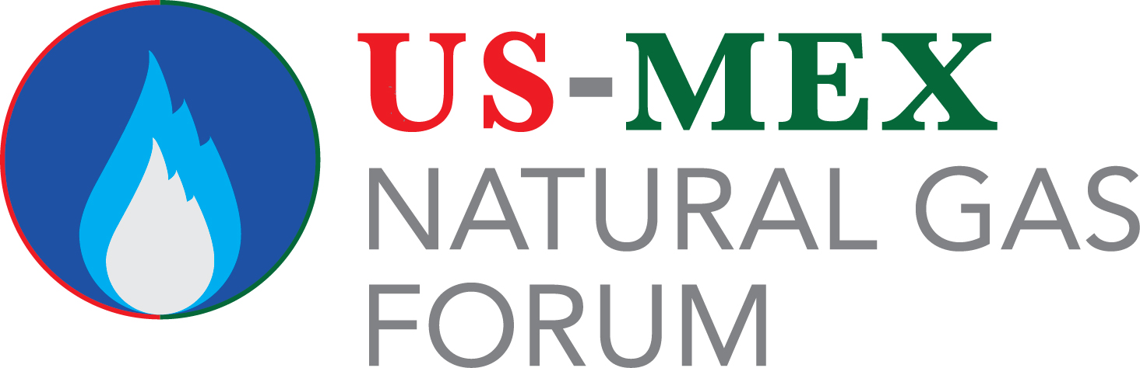

2017 Sponsorship Reservation Form

- CHOICE OF SPONSORSHIP(S)
My company wishes to reserve the following sponsorship(s) at the 2017 US-Mex Natural Gas Forum, held Aug. 14-16, 2017, at the Hyatt Riverwalk in San Antonio, TX:

_____ Corporate Sponsorship

_____ Kiosk Sponsorship

_____ Badge Lanyard Sponsorship

_____ Hotel Card Key Sponsorship

_____ Reception Sponsorship

Total Ordered $ _____________________________

Notes: __________________________________________________________________________________________

CONTACT INFORMATION

Name: Title:

Company:

Address:

City/State/Zip______________________________________________________________________________________________________

Phone: Fax: E-Mail:

Company website:_____________________________________________

METHOD OF PAYMENT

- Credit Card: MasterCard Visa AMEX Discover

Card # ______________________________________________ Exp. Date ________________Sec. Code ______________

Name on Card ________________________________________Signature ____________________________________________

B.) Please Invoice C.) Check Enclosed
Please return form to Christy Coleman (christyc@tradefairgroup.com):
US/MEX Forum, 11000 Richmond Ave. # 690, Houston, TX 77042, USA
Tel: 713-343-1873

I hereby apply for a sponsorship for the 2017 US-Mex Natural Gas Forum. By signing the application above, I agree to pay the total fee of the sponsorship. As a sponsor, I also agree to pay the sponsorship fee within 30 days after receiving the invoice from Access Intelligence, the parent company of the US-Mex Natural Gas Forum.

Signature _________________________________________________ Date _____________________

